**ETL Project**

Kenny Dao

Sean Pei

Our task was to source, process and load the data to a production database. We used Jupyter notebook to pull API from selected data source, Pandas library for our data manipulation and creating DataFrames. Then, we utilized PgAdmin to load the data into Postgresql database and make it accessible online using Google Cloud Platform.

Data source:

1. Kaggle: <https://www.kaggle.com/bahramjannesarr/goodreads-book-datasets-10m?select=book900k-1000k.csv> (dataset is being updated every 2 days)
2. API: <https://www.goodreads.com/api>
3. <https://www.kaggle.com/pelinsoylu/amazon-the-most-read-books-of-the-2019-dataset> (bestsellers with categories.csv)

EXTRACT

We used the books data (book900k-1000k.csv) from Kaggle. It’s a csv file with over 40k rows and 20 columns that content lot of information and a good starting point for us.

We also used the bestsellers with categories data to create the API request (from Goodreads API) about information about authors.

TRANSFORM

Having found the books dataset on Kaggle, we have chosen to make more information relating to books available for inquiries, such as finding the most popular book titles (bestsellers title by year), the highest-rated books, recently released titles, etc. For books table, 11 columns were removed and cleaned up/convert to suitable forms. The focused columns are BookId, Title, Rating, ISBN, PublishY, PublishM, PublishD and Language.

We have pulled API from Goodreads to get more information about authors. The data is in XML file so we converted into dataframe using Jupyter notebook and created an authors table, includes AuthorId, AuthorName, Gender, and Hometown columns. At present, the authors table has 244 records.

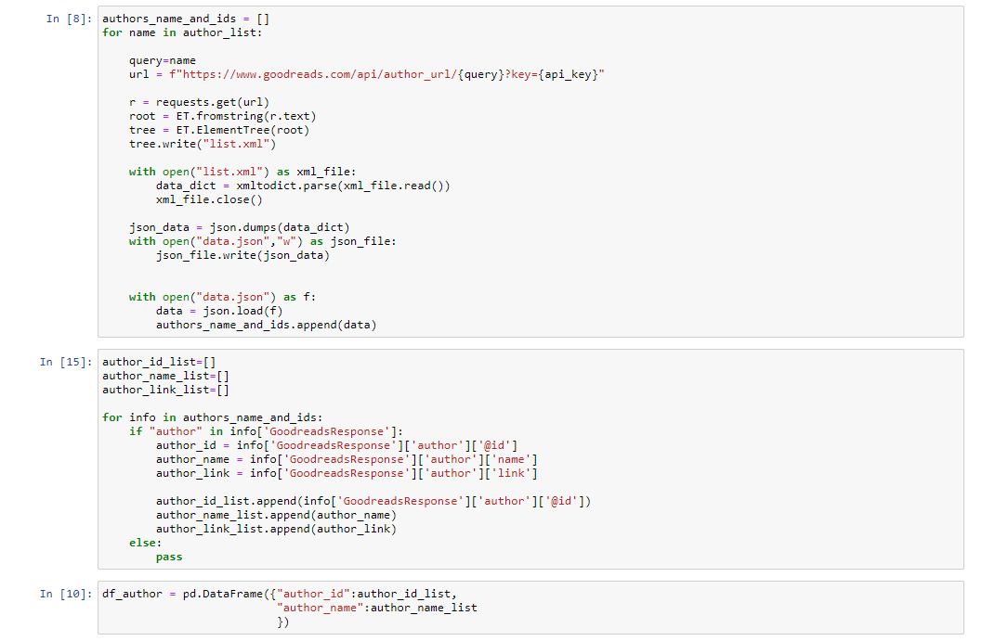

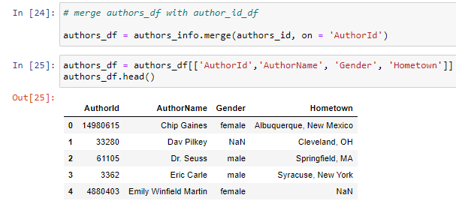

We then processed and merged the data from books data, bestseller data, authors (created above) to form an author_book dataframe that make a relation between author and book, adding BestSeller feature (to determine whether a book title is one of the bestseller books).

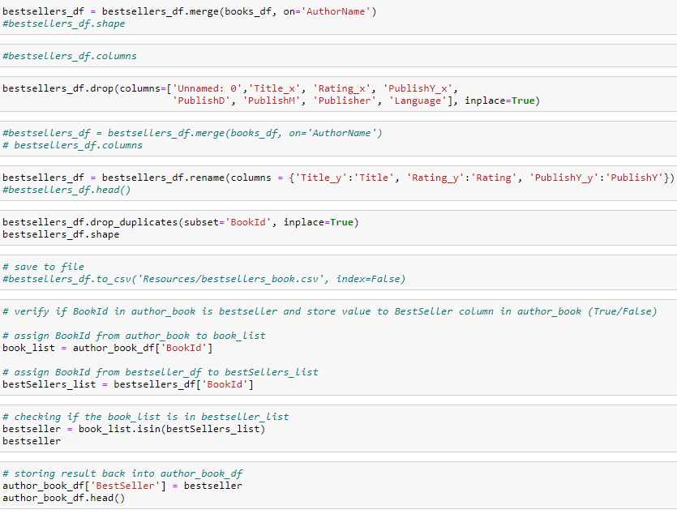

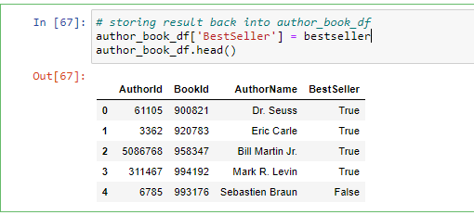

LOAD

We loaded our CSV into Postgresql as our database and made it available on-line using google cloud platform. After that, we have tested out with some queries as below.

In summary, based on our observation and finding, there are multiple books dataset available. However, the data format is vastly different and still much of missing data (null value), which we can further update a long the way. Applying Postgresql to store database about books would be an alternative to present data in a structured data for inquiries.

